**Dressing Princess**

**Manual**

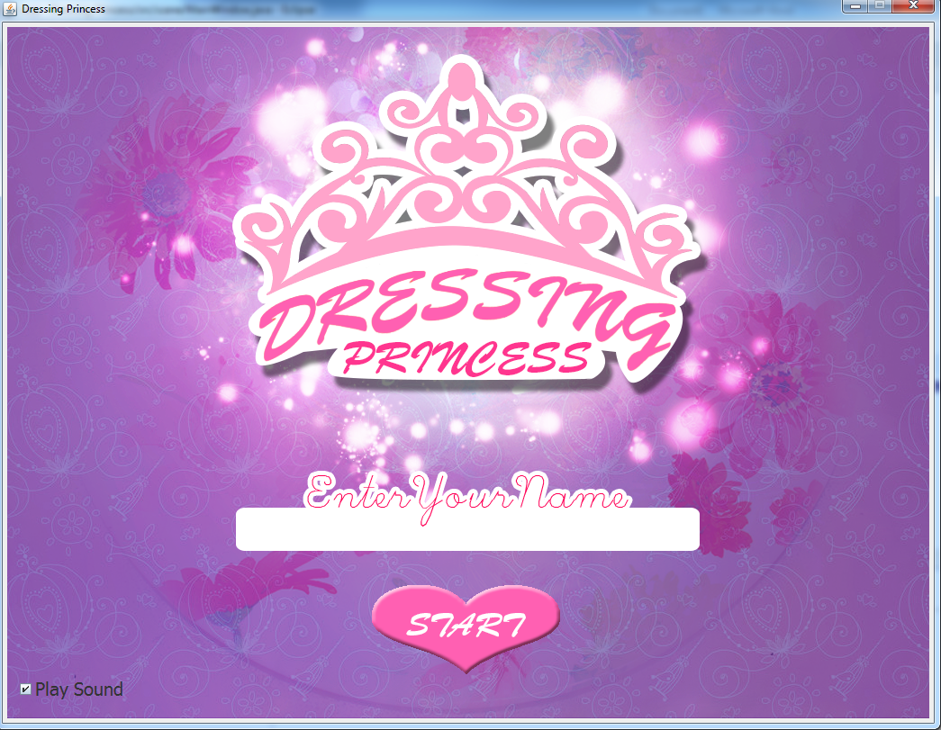

5731083221 - Peerawut Luengruengroj

5731101921 - Sasicha Poonpol

2110215 Programming Methodologies I

Semester 1/2015

Chulalongkorn University

**Dressing Princess**

Description

Dressing Princess is single player game. The player was requested to complete math puzzle and collect score to help princess buy new dress for her marriage. Player has to answer the equations’ answers in the black space as much as possible within 1 minute. Every right answer player will get score up to difficultly. When player can collect enough score, player can buy dress from shop to complete the game.

UML Diagram

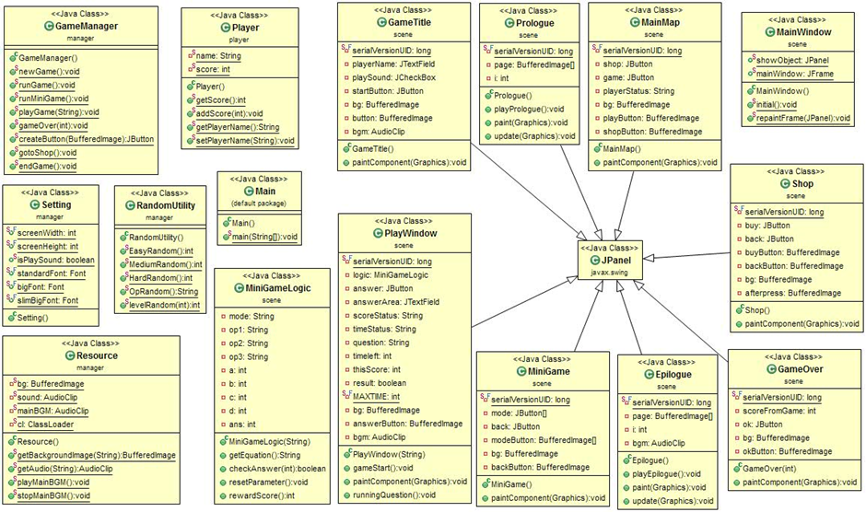

**Implementation Detail**

1. Class Player

This class contain in package “player”. This class used for keep player data.

1.1 Field

**-** static String name;this field keep player’s name.

- static int score; this field keep player’s total score. The default value of this field is 0.

1.2 Method

+ static int getScore(); return player’s total score.

+ static void addScore(int score); add player’s score.

+ static String getPlayerName(); return player’s name.

+ static void setPlayerName(String name); set player’s name.

2. Class GameManager

This class contain in package “manager”. This class used for manage every scene in game.

2.1 Method

+ static void newGame(); use for create prologue, add prologue to game’s frame and play prologue’s slideshow.

+ static void runGame(); use for create game’s main map and add to game’s frame.

+ static void runMiniGame(); use for create mini game scene and add to game’s frame.

+ static void playGame(String mode); use for create mini game’s playing scene and add to game’s frame. This method used to start mini game too.

+ static void gameOver(int total); use for create game over scene after ending mini game and add to game’s frame.

+ static void gotoShop(); use for create shop scene and add to game’s frame.

+ static void endgame(); use for create ending scene when player buy dress successfully and add to game’s frame. This method also plays ending scene slideshow.

+ static JButton createButton(BufferedImage icon); used for create jButton with icon from BufferedImage. Also make this JButton’s background translucent and borderless.

3. Class RandomUtility

This class contain in package “manager”. This class is utility for random integer and operand.

3.1 Method

+ static int EasyRandom(); return the random integer from 1 to 10.

+ static int MediumRandom(); return the random integer from 10 to 100.

+ static int HardRandom(); return the random integer from 100 to 1000.

+ static String OpRandom(); return the String of operand (+ or -) which 50% is “+” and other is “-“.

+ static int levelRandom(int level); return the random integer from 1 to level.

4 Class Resource

This class contain in package “manager”. This class used for load BufferedImage and AudioClip. Also, used for play and stop AudioClip.

4.1 Field

- static BufferedImage bg; this field used for contain BufferedImage from ClassLoader.

- static AudioClip mainBGM; this field used for contain major background music AudioClip (bgm1.wav) which use in most scene.

- static AudioClip sound; this field used for contain AudioClip from ClassLoader.

- static ClassLoader cl; This field is ClassLoader used for load image and sound from outside files.

4.2 Method

+ static BufferedImage getBackgroundImage(String directory); return the BufferedImage from certain “directory” path and file.

+ static AudioClip getAudio(String directory); return the AudioClip from certain “directory” path and file.

+ static void playMainBGM(); load file “bgm1.wav” from ClassLoader and play it.

+ static void stopMainBGM(); stop playing “bgm1.wav”.

5. Class Setting

This class contain in package “manager”. This class used for contain constant value in game.

5.1 Field

+ static final int screenWidth; contain value of this game’s screen width. The value always be 1024;

+ static final int screeHeight; contain value of this game’s screen height. The value always be 768;

+ static boolean isPlaySound; contain playing sound setting if it’s is true, the game will play sound. If not, the game won’t play sound. This field is true by default.

+ static final Font standardFont; contain font pattern. The font style of this field is “Tahoma” font, plain style has size 20.

+ static final Font slimBigFont; contain font pattern. The font style of this field is “Tahoma” font, plain style has size 30.

+ static final Font bigFont; contain font pattern. The font style of this field is “Tahoma” font, bold style has size 40.

6. Class GameTitle

This class contain in package “scene”. This class is JPanel and the picture is look like the Figure 1.



Figure 1. GameTile

6.1 Field

- static final long serialVersionUID; this field is auto generated by compiler, the value is 1L by default. (Provided)

- JTextfield playerName; JTextfield for player to enter his or her name. This field is translucent and borderless. This field place under “Enter Your Name” as Figure 1. The font used in this text area is “Setting.standardFont”.

- JCheckbox playSound; JCheckbox which lets player choose to play or not play sound in game.

- JButton startButton; the game starting button. When clicked, it will call GameManage to load prologue. If the “playerName” is blank, It will show dialog to tell people as Figure 2.

- BufferedImage bg; used for contain this panel’s background image.

- BufferedImage button; used for contain “startButton” icon.

- AudioClip bgm; used for contain specific background music for this scene.

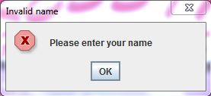

Figure 2. Showed dialog when “playerName” is empty.

6.2 Construction

+ GameTitle(); add component (playerName, playSound, startButton) as Figure 1. As well as load background image (GameTitle.png) and “startButton” icon (Start Button.png) and load, play background music from “sound/bgm2.wav”.

Note that if player request not to play sound. It will stop playing any sound and it will play when player request to play sound again.

When player click on “Start” button this will call GameManager.newGame() to run the game’s prologue and play the sound effect “click.bgm”. you have to wait 1 second before load prologue. Note that this will not allow player set name as blank. If player do, show the dialog as show in figure 2 and play sound effect “wrong.wav” instead. Every clicking on this button, it will make button pressed effect by load “Start Button (pressed).png”.

6.3 Method

+ void paintComponent(Graphics g); draw background image to this panel. This method is overriding.

7 Class Prologue

This class is “JPanel” and contain in package “scene”. This class used for playing slide show as show in figure 3.

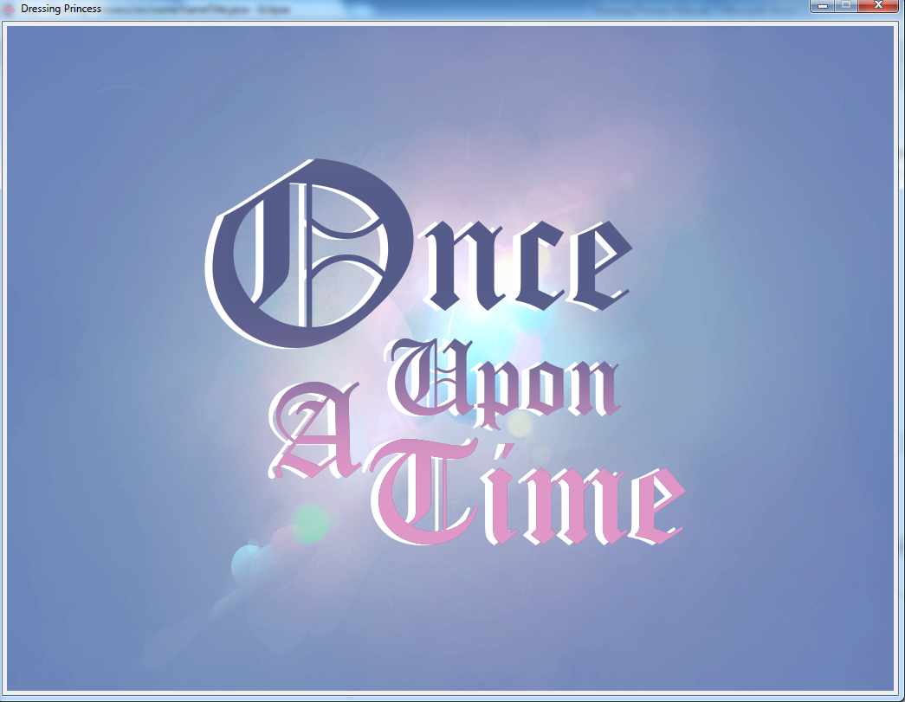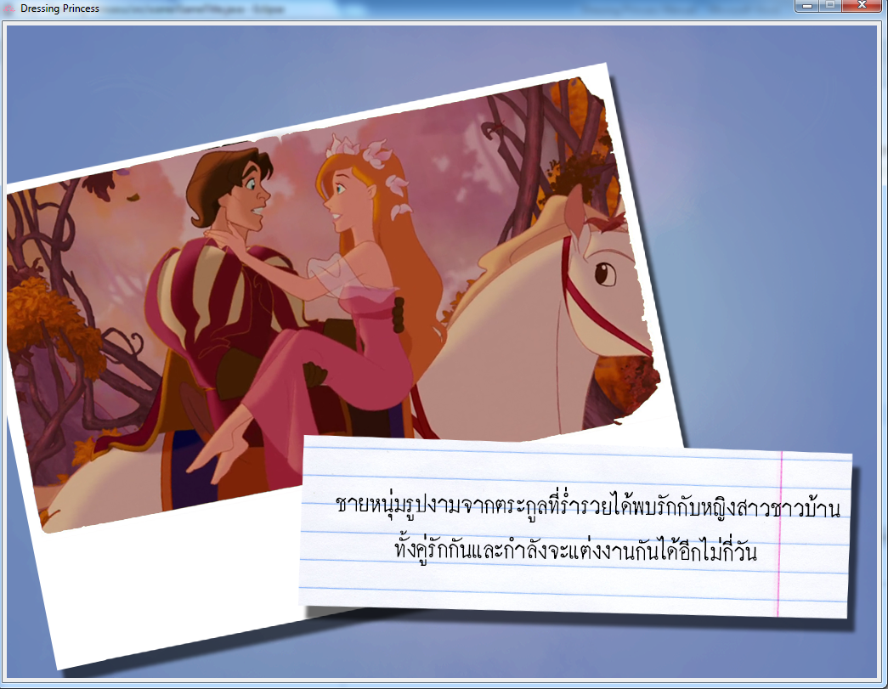

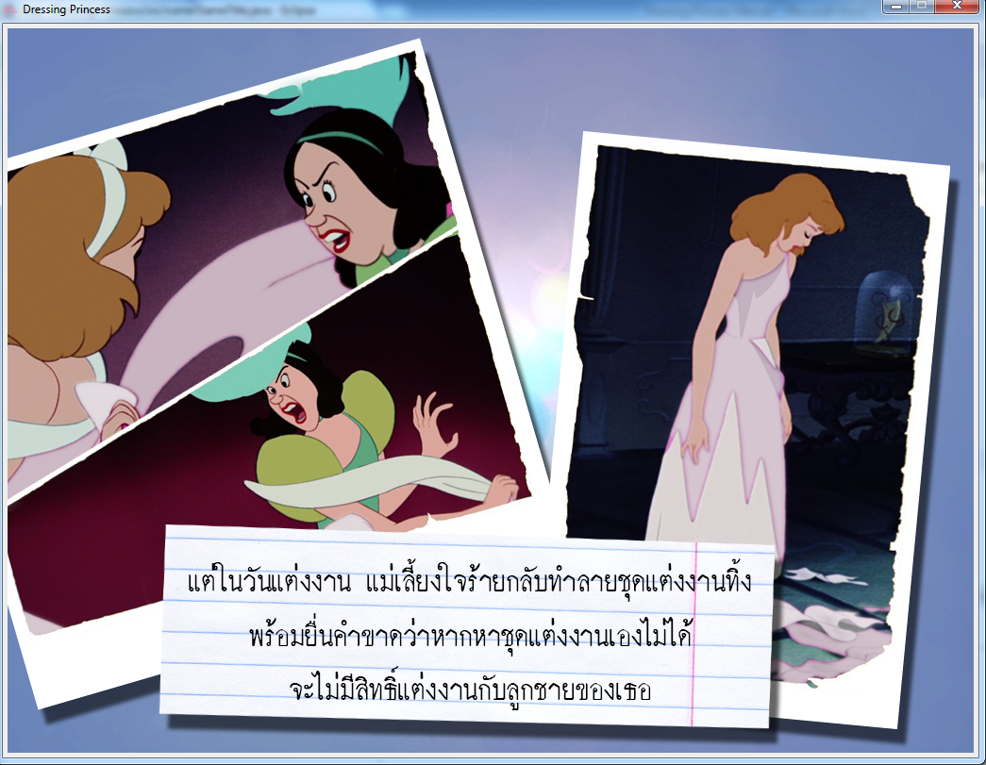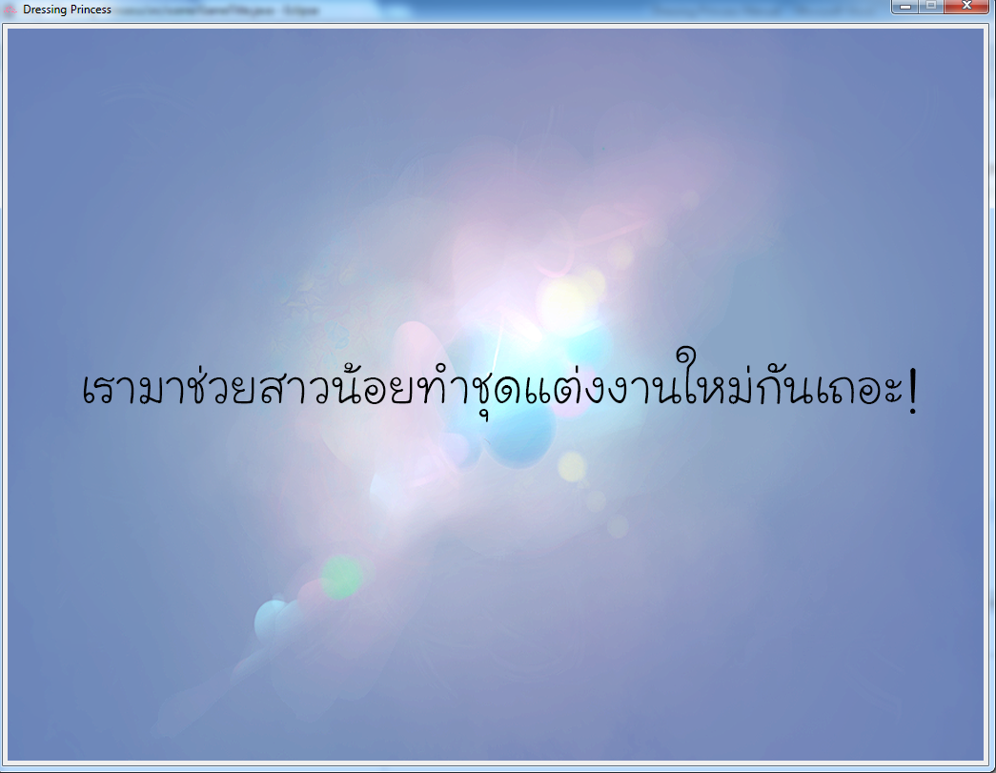

Figure 3. Prologue slide show (ordered)

7.1 Field

- static final long serialVersionUID; this field is auto generated by compiler, the value is 1L by default. (Provided)

- BufferedImage page[]; this field is array of BufferedImage with contain all slide show image.

- volatile int i; this filed is scene counter which use for index showing image, because this field used in multiple method, it has to make Thread-safe attribute.

7.2 Construction

+ Prologue(); this construction will assign image to page[] (page0.png, page1.png, …, page3.png) and if player has requested to play sound this will play major background music (bgm1.wav).

7.3 Method

+ synchronized void playPrologue(); this method will index slide show image as figure 3. The time between scenes is 2 seconds. And when slide show is end wait 2 seconds and load “MainMap” via “GameManager.RunGame()”. Because this method has to run independency, it has to make Thread-safe method.

+ void paint(Graphics g); this method use for paint scene from updated scene. This method is overriding.

+ void update(Graphics g); this method will draw image from page[]. When change index change, this method will play next image. This method is overriding.

8. Class MainMap

This class is “JPanel” and contain in package “scene”. This class will let the player choose play mini game or go to shop and also show player’s name and player’s total scores as show in figure 4.

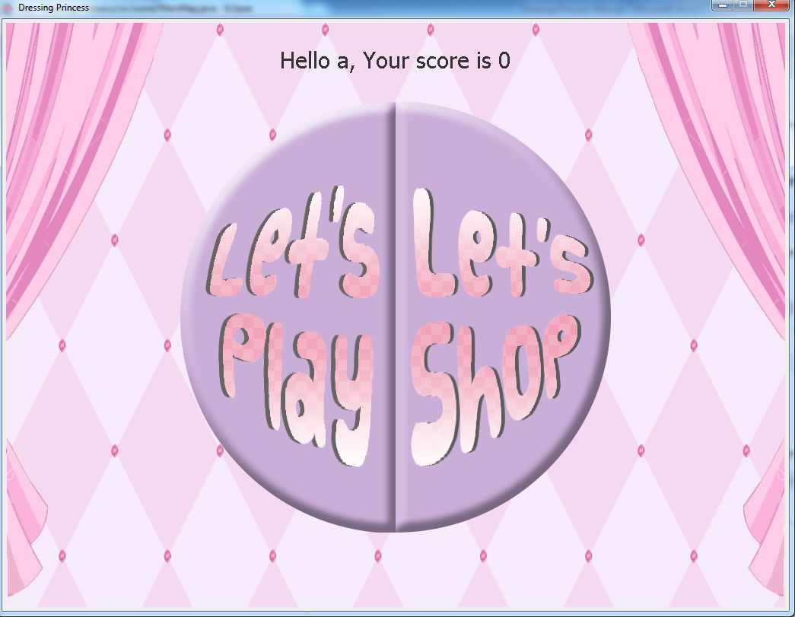

Figure 4. MainMap (Player’s name is “a” and his or her score is 0)

8.1 Field

- static final long serialVersionUID; this field is auto generated by compiler, the value is 1L by default. (Provided)

- JButton game; button for play mini game.

- JButton shop; button for go to shop;

- String playStatus; the text which show on the top of scene. Pattern is as same as showed in figure 4.

- BufferedImage bg; image for this scene background (Background.png).

- BufferedImage playButton; image for “game” button (Play Button.png).

- BufferedImage shopButton; image for “shop” button (Shop Button.png).

8.2 Construction

+ MainMap(); load image of button and background. Create component assigned in 8.1 and add to this scene as show in figure 4.

“game” button event : load “Play Button (pressed).png” to make button clicking effect and play “clicking.wav” if player request playing sound. Note that you have to wait for 1 second to let the clicking sound end and load mini game starting scene by calling “GameManager.runMiniGame()”.

“shop” button event : load “Shop Button (pressed).png” to make button clicking effect and play “clicking.wav” if player request playing sound. Note that you have to wait for 1 second to let the clicking sound end and load shop scene by calling “GameManager.gotoShop()”

8.3 Method

+ void paintComponent(Graphics g); used for draw background image and player’s status into scene as showed in figure 4. Font for string is “Setting.slimBigFont”. This method is overriding.

9. Class MiniGame

This class is “JPanel” and contain in package “scene”. This class used as mini game starting scene which let player choose difficulty of mini game. The figure 5. is show picture of mini game starting scene.

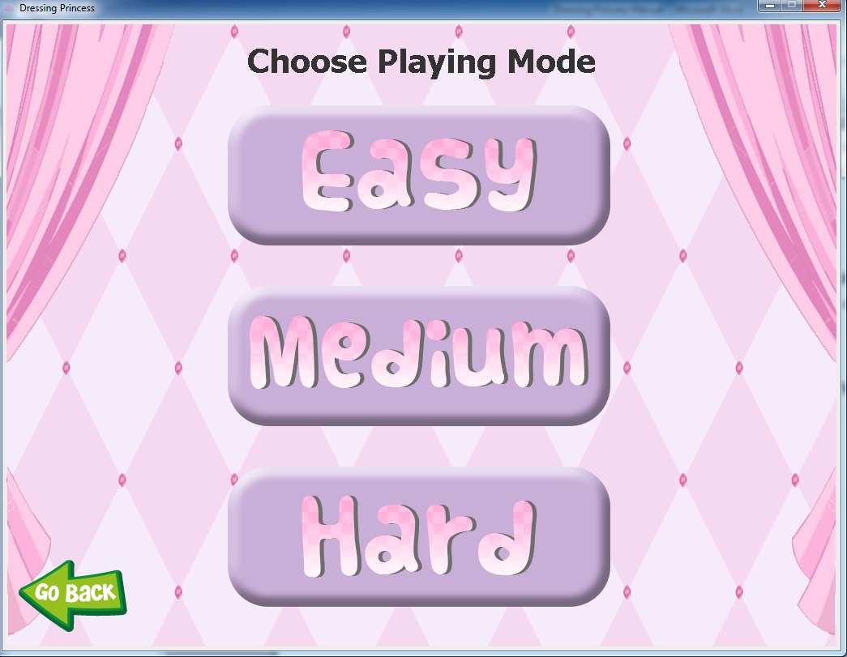

Figure 5. MiniGame scene

9.1 Field

- static final long serialVersionUID; this field is auto generated by compiler, the value is 1L by default. (Provided)

- JButton mode[]; this field is array of playing mode button (mode[0] is for easy mode, mode[1] is for medium mode and mode[2] is for hard mode).

- JButton back; button for go back to MainMap.

- BufferedImage modeButton[]; array of playing mode button image the order is same as “mode[]” (“Easy Button.png”, “Medium Button.png” and “Hard Button.png”).

- BufferedImage backButton; image for back button (Back.png).

- BufferedImage bg; this field is background image of this scene (Background.png).

9.2 Construction

+ MiniGame(); load image as assign in 9.1 . Create component as assign in 9.1 and add to scene as figure 5.

Mode[0] button event : load image “Easy Button (pressed).png” to make button clicking effect and load sound “click.wav” if player request playing sound and wait 1 second before loading “PlayWindow” by calling “GameManager.playGame(“easy”)”.

Mode[1] button event : load image “Medium Button (pressed).png” to make button clicking effect and load sound “click.wav” if player request playing sound and wait 1 second before loading “PlayWindow” by calling “GameManager.playGame(“medium”)”.

Mode[2] button event : load image “Hard Button (pressed).png” to make button clicking effect and load sound “click.wav” if player request playing sound and wait 1 second before loading “PlayWindow” by calling “GameManager.playGame(“hard”)”.

back button event : wait 100 millisecond and go back to MainMap.

When any mode button clicked, stop major background music.

9.3 Method

+ void paintComponent (Graphics g); draw text as show in figure 5. and draw background image (Background.png) to this scene. Font for string is “Setting.bigFont”. This method is overriding.

10. Class PlayWindow

This class is “JPanel” and contain in package “scene” This class is mini game playing window. The equation will be show in windows as figure 6. When answer the question press “Enter” on keyboard or click “Answer” button. If the answer is correct, the score will add.

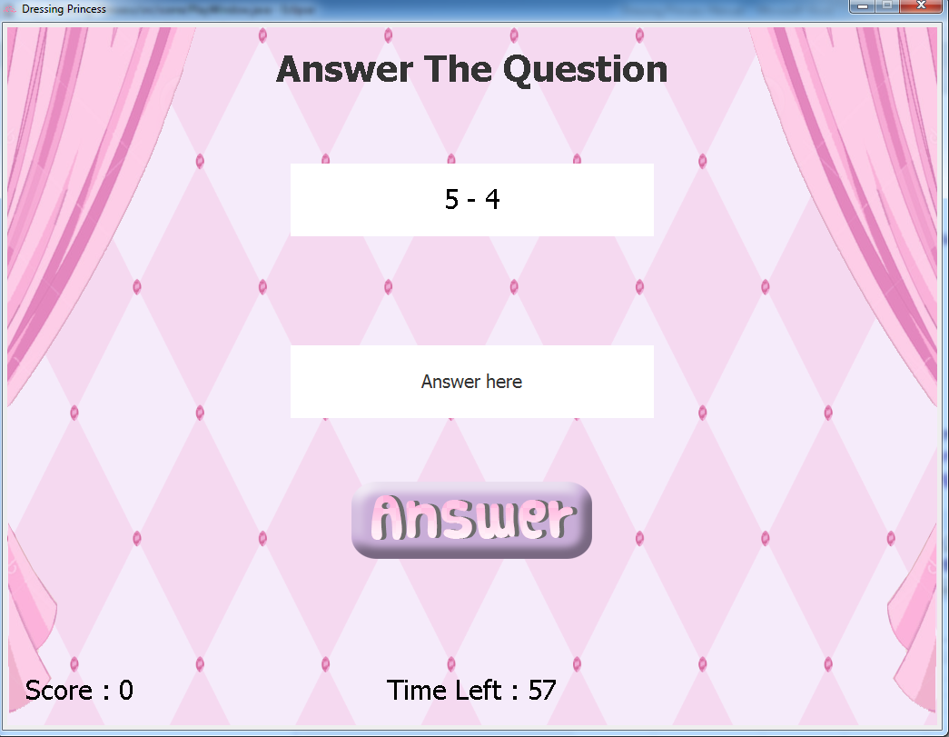

Figure 6. PlayWindow

10.1 Field

- static final long serialVersionUID; this field is auto generated by compiler, the value is 1L by default. (Provided)

- MiniGameLogic logic; this field is this mini game logic.

- volatile JButton answer; answer button to check the answer. This field is run on Timer thread so this field has to make Thread-safe attribute.

- volatile JTextField answerArea; answering text area. This text area is borderless and has string “Answer here”. When this field is clicked, this field will turn to blank space. This field is run on Timer thread so this field has to make Thread-safe attribute. Font for this text area is “Setting.standardFont”.

- volatile String scoreStatus; a string which show player’s score in this game as show in figure 6. Because this field modify by multiple method and thread, this field has to make Thread-safe attribute.

- volatile String timeStatus; a string which show time left as show in figure 6. Because this field modify by multiple method and thread, this field has to make Thread-safe attribute.

- volatile String question; a string of equation. Because this field modify by multiple method and thread, this field has to make Thread-safe attribute.

- votalite int timeLeft; remaining time, has value “MAXTIME” by default. Because this field change its value by Timer thread, this field has to make Thread-safe attribute.

- volatile int thisScore; score for this game, has value 0 by default. Because this field change its value by Timer thread, this field has to make Thread-safe attribute.

- boolean result; Boolean of result of answering the question. It’s true when the answer is correct and false when the answer is wrong.

- static final int MAXTIME; contain max time for this game, its value is always be 60.

- BufferedImage bg; image for this scene background (Background.png).

- BufferedImage answerButton; image icon for “answer” button (Answer Button.png).

- AudioClip bgm; background music for this scene (bgm3.wav).

10.2 Construction

+ PlayWindow(String mode); create component assigned in 10.1 and add to this scene as show in figure 6. Load image as assign in 10.1. If player request play sound,load and play background music. Generate first question from “logic”.

10.3 Method

+ void gameStart(); When called, the game will begin by start Timer thread. In this method, timeLeft will reduce by 1 every second. When time’s up, stop playing background music if played and play “correct.wav” 3 times, add score from this game to player’s total score and then load “GameOver” scene by calling “GameManager.gameOver(thisScore)”. This method also contains action listener for “answer” button and key listener for “answerArea” too. When clicked on answer button or press enter on keyboard it will called “runningQuestion()” method.

+ void runningQuestion(); This method used for

1) Check the answer if it wrong or right. If correct, add score for this scene and play “correct.wav” when player request sound. If wrong or the answer from player is not integer show dialog as figure 7. and play “wrong.wav” when player request sound.

2) This method will make button clicking effect (Answer Button (pressed).png). Note that press keyboard is similar to click answer button.

3) Whether wrong or right answer, this method will generate new question. Note that the question will not be generated if player answer in wrong format.

In this method some of statement need to do Thread-safe to prevent redundantly repaint.

+ void paintComponent (Graphics g); This method use for draw background image, banner, question, scoreStatus and timeStatus. The implement detail is

1) banner : draw string “Answer The Question” in the top center of scene as show in figure 6. Font is “Setting.bigFont”.

2) question : draw the equation as showed in figure 6. Note that there is white filled white rectangle behind this text. Font is “Setting.slimBigFont”.

3) scoreStatus : draw score bar as showed in figure 6.

4) timeStatus : draw time bar as showed in figure 6.

This method is overriding.

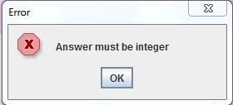

Figure 7. Error Dialog, showed when the answer is not integer or blank.

11. Class MiniGameLogic

This class contain in package scene. This class used for generated equation and check the answer of generated equations.

11.1 Field

- String mode; this field used for determine difficultly level.

- String op1; 1st operand.

- String op2; 2nd operand.

- String op3; 3rd operand.

- int a; 1st integer for question.

- int b; 2nd integer for question.

- int c; 3rd integer for question.

- int d; 4th integer for question.

- int ans; answer of this equation.

11.2 Construction

+ MiniGamelogic(String mode); assign defau;t value to all field. All operand is blank string. All integer is 0.

11.3 Method

+ String getEquation(); this method used for generate equation string as show in figure 6. The number and operand is separate by space. This method, all you have to do is

1) Random an operand to “op1”. The equation for “easy” mode has only two numbers and one operand and all number in this equation is not more than 100.

2) If there is “medium” mode, random an operand to “op2”. In this case, the first number must be between 10 and 100 only and the other two numbers can be any positive number that not more than 100. The equation must have only 3 numbers and 2 operands.

3) If there is “hard” mode, random an operand to “op2” and “op3”. In this case, the first number must be between 100 and 1000 only and the other three numbers can be any number that not more than 1000. The equation must have only 4 numbers and 3 operands.

4) The equation can be controlled to not too hard by random case of generated numbers. You can make condition that one of number of the equation must not more than 10 or 100 too.

+ boolean checkAnswer (int answer); this method used for check the answer from player whether correct or not. If the answer is correct by the question, return true unless return false.

+ void resetParameter (); this method use for reset all numbers and operands to their default value as assign in 11.2. Note that this method must be called before generated new question.

+ int rewardScore(); this method used for return the score if player answer the question correctly. This method will return 5 for easy mode, 20 for medium mode and 40 for hard mode.

12 Class GameOver

This class is “JPanel” and contain in package “scene”. This class will be used when the mini game is end. This class will show the result of the game and player’s total score as show in figure 8.

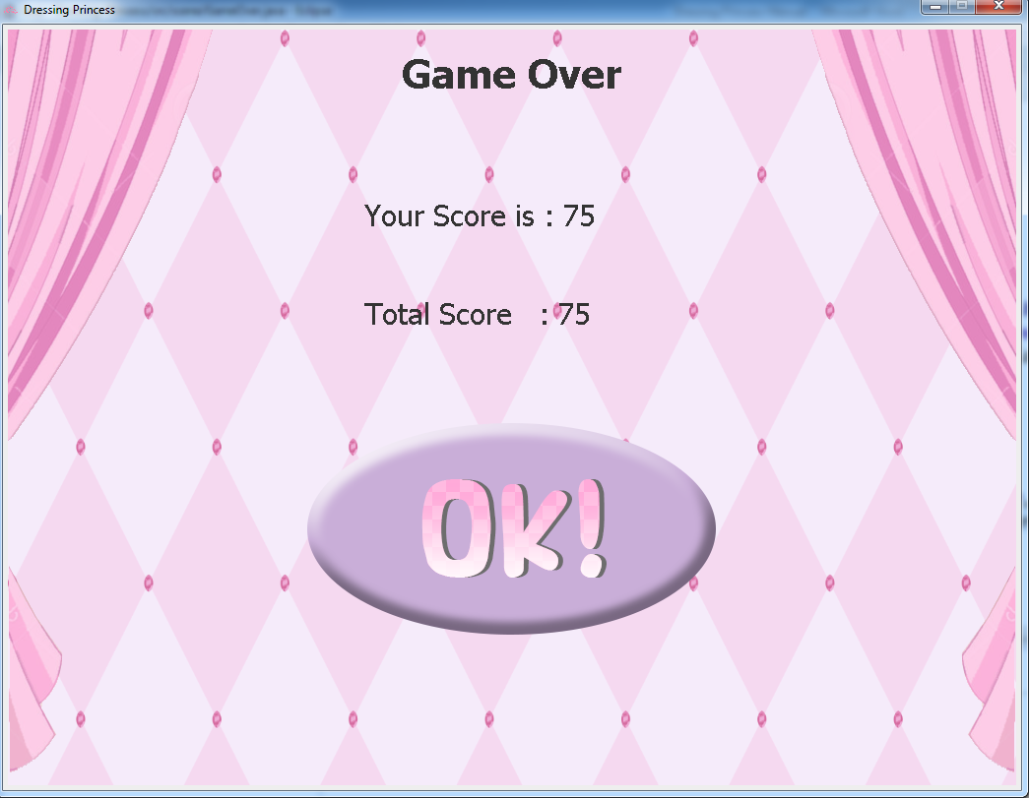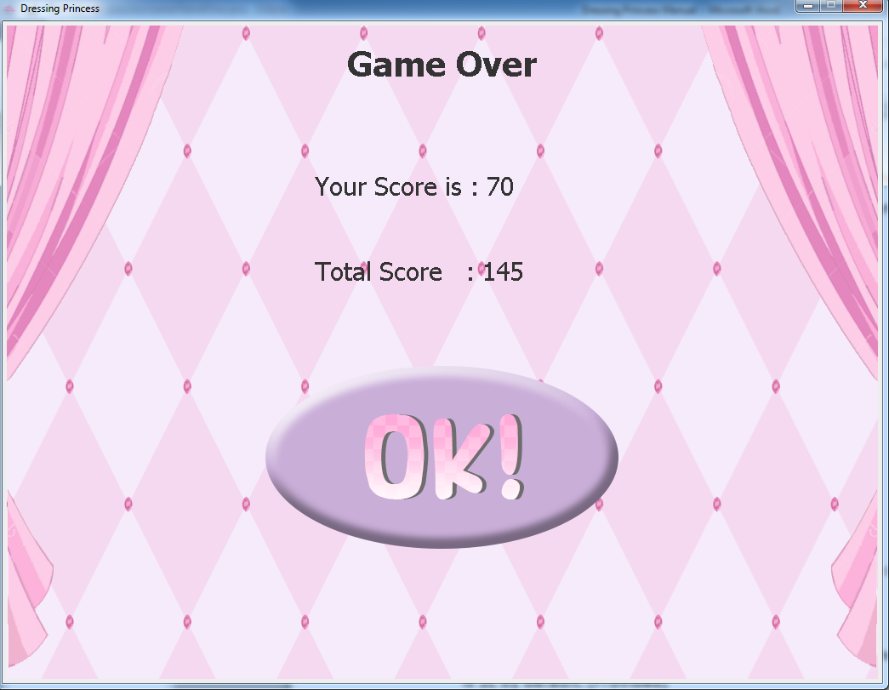

Figure 8. GameOver from first play (left) and from second play (right)

12.1 Field

- static final long serialVersionUID; this field is auto generated by compiler, the value is 1L by default. (Provided)

- int scoreFromGame; this field is the score from the game that player just play.

- JButton ok; ok button, when clicked, player will return to “MainMap” scene.

- BufferedImage bg; background image for this scene (Background.png).

- BufferedImage okButton; image for “ok” button icon (OK Button.png).

12.2 Construction

+ GameOver(int score); create component and add to this scene as showed in figure 8. If player request sound, play major background music (bgm1.wav).

Ok button event: When clicked, play sound effect “click.wav” if player requested sound. Load image “OK Button (pressed).png” to make button pressing effect and wait 1 second before go back to “MainMap”

12.3 Method

+ void paintComponent(Graphics g); this method used for draw background image and the string as show in figure 8. This method is overriding.

13 Class Shop

This class is “JPanel” and contain in package “scene”. This class is used for ending game after player collect enough score to buy the dress as showed in figure 9.

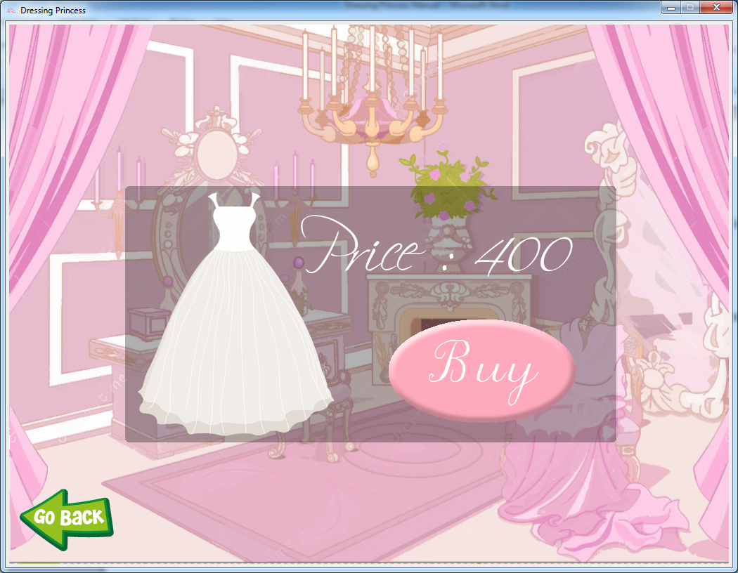

13.1 Field

- static final long serialVersionUID; this field is auto generated by compiler, the value is 1L by default. (Provided)

- static JButton buy; this button used for buy dress and lead to ending scene.

- static JButton back; this button used for go back to “MainMap”.

- static BufferedImage bg; background image for this scene (Shop.png).

- static BufferedImage buyButton; image for “buy” button icon (Buy Button.png).

- static BufferedImage afterpress; image for pressed “buy” buttom icon (AfterBuy Button.png).

13.2 Construction

+ Shop(); load image as assign in 13.1, create component and add to this scene as showed in figure 9.

Back button event: wait 100 millisecond and go back to “MainMap” scene.

Buy button event: when clicked, set icon of this button to afterpress to make button pressing effect. If player has not enough score to buy dress, show dialog as showed in figure 10. and play sound “wrong.wav” if player requested sound. If player has enough score to buy dress, show dialog as showed in figure 11. and go to ending scene by called “GameManager.endGame()”.

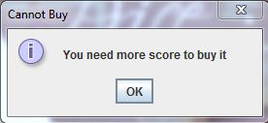

Figure 10. Dialog showed when has not enough score.

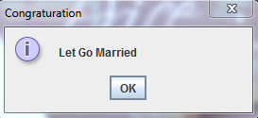

Figure 11. Dialog showed when buy dress successfully.

13.3 Method

+ void paintComponent(Graphics g); draw background image as showed in figure 9. This method is overriding.

14 Class Epilogue

This class is “JPanel” and contain in package “scene”. This class will play ending scene slide show and when slide show’s ending, show the dialog and when click the ok button. The game will close as showed in figure 12. and figure 13.

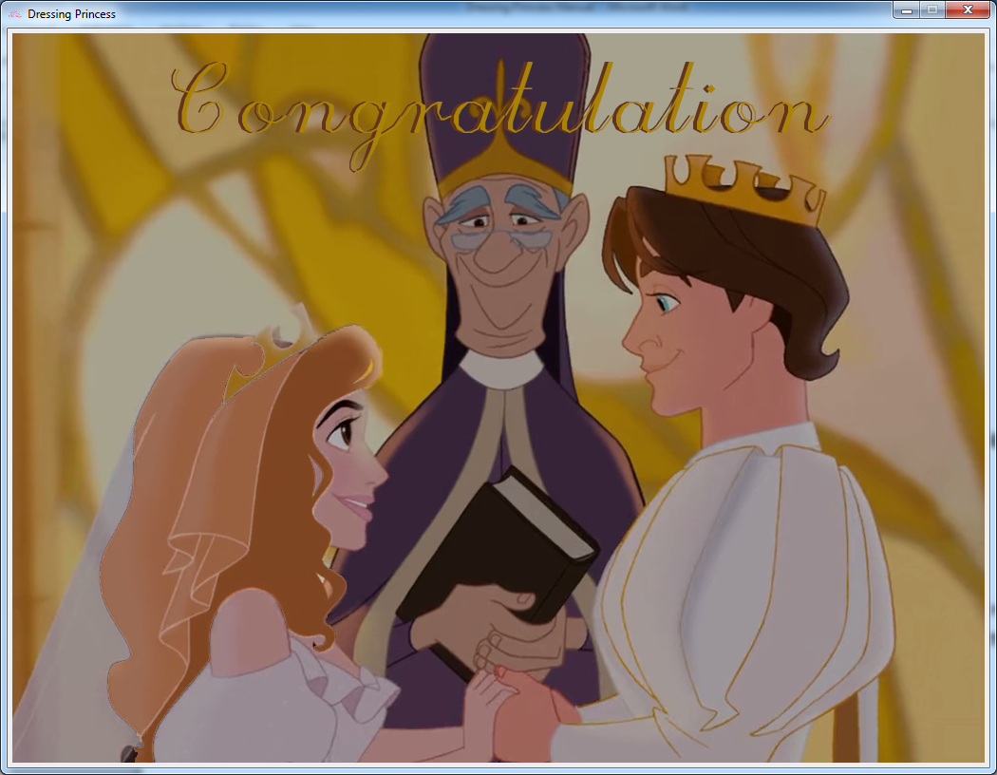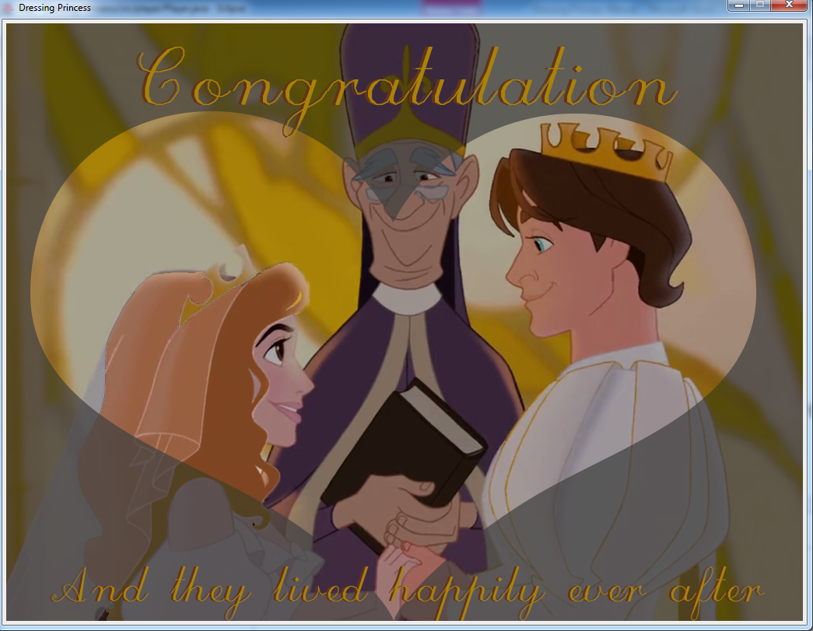

Figure 12. Ending scene slide show (ordered)

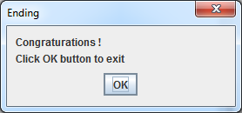

Figure 13. Close game dialog

14.1 Field

- static final long serialVersionUID; this field is auto generated by compiler, the value is 1L by default. (Provided)

- BufferedImage page[]; this field is array of BufferedImage with contain all slide show image (End1.png and End2.png).

- volatile int i; this filed is scene counter which use for index showing image, because this field used in multiple method, it has to make Thread-safe attribute.

- AudioClip bgm; AudioClip for background music for this scene (Wedding theme.wav).

14.2 Construction

+ Epilogue(); load image as assign in 14.1 and set default value of i to 0. If player requested sound, load and play sound as assign in 14.1.

14.3 Method

+ synchronized void playEpilogue(); this method will index slide show image as figure 12. The time between scenes is 2 seconds. And when slide show is end wait 2 seconds before show ending dialog in figure 13. When close the dialog the game will be exit (close window). Because this method has to run independency, it has to make Thread-safe method.

+ void paint(Graphics g); this method use for paint scene from updated scene. This method is overriding.

+ void update(Graphics g); this method will draw image from page[]. When change index change, this method will play next image. This method is overriding.

15 Class MainWindow

This class contain in package “scene”. The function of this class is to make the “JFrame” windows and repaint the frame when change the scene.

15.1 Field

+ static volatile JPanel showObject; this field contain the scene that will be paint in the window. Because this field involve in thread so this field has to make Thread-safe attribute.

+ static volatile JFrame mainWindow; this field is main window of this game. Because this field is repainted by multiple method and thread so this field has to make Thread-safe attribute.

15.2 Method

+ static void initial(); this method is create frame, load this game’s icon and make the starting scene for the game (GameTitle). Because some scene may use by thread so it has to make swing thread-safe.

+ static void repaintFrame(JPanel newFrame); this method is used for repaint “showObject” with new scene. Because this method may use by thread so it has to make swing thread-safe.

16 Class Main

This class is main class of this game and contain in default package.

16.1 Method

+ static void main(String[] args); this will call method “MainWindow.initial()” to create the main window of this game.

**How to play**



**Check when you want to play sound. Uncheck if not.**

**1. Enter your name here**

**2. Click here**

- Your name must not be blank.

- When click start the wait until prologue is end.

- This game cannot be saved if you exit the game everything will be reset.

- You can exit the game anytime by click close button on the top right of window.



**Click here to play game**

**Click here to go to shop**

**This is your total score**



**Easy mode: a ± b**

**Go back to menu**

**Medium mode: a ± b ± c**

**Hard mode: a ± b ± c ± d**



**Your remain time**

**3. Press this button on press “ENTER” to submit your answer.**

**2. Type you answer here.**

**1. Find this equation’s answer.**

- Answer as much questions as possible within 60 second.

- Answer must be integer only. (No float)

- Answer can be either positive or negative integer and also be 0.

- Answer must look like these: 12 or -20 or 0

- You will get 5 score per right answer in easy mode, 20 in medium and 40 in hard mode.



**Your score from game**

**Your total score since start this game**

**Click here to go back to menu**



**Click here to go back to menu**

**Click here to buy dress**

- Dress can buy when your total score is not less than 400.

- When buy dress successfully game will lead to ending scene.